Fashion-MNIST Classification Project

Objective of the Project
The objective of this project is to fine-tune a pre-trained ResNet-50 model to classify images from the Fashion-MNIST dataset. This dataset consists of grayscale images of various clothing items, divided into 10 categories. The project showcases the use of transfer learning for image classification and demonstrates how to preprocess data, train a deep learning model, evaluate its performance, and visualize results.

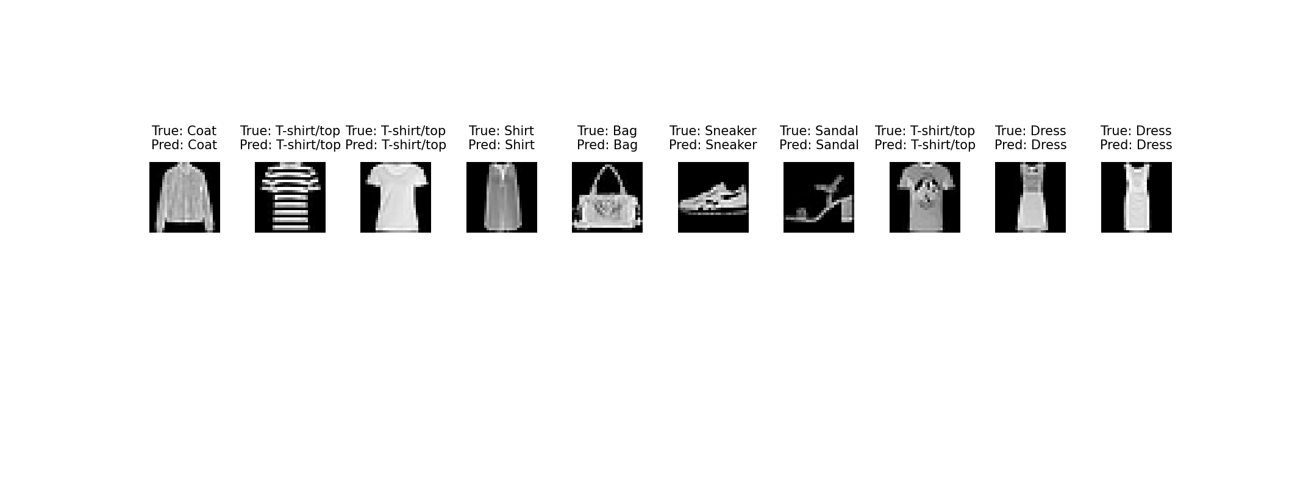

Project Structure and Python Files
1. data_loading.py
Purpose:
This file is responsible for loading and preprocessing the Fashion-MNIST dataset. It normalizes the data and converts grayscale images to a format compatible with the ResNet-50 model.
Key Functions and Methods:
- load_data():
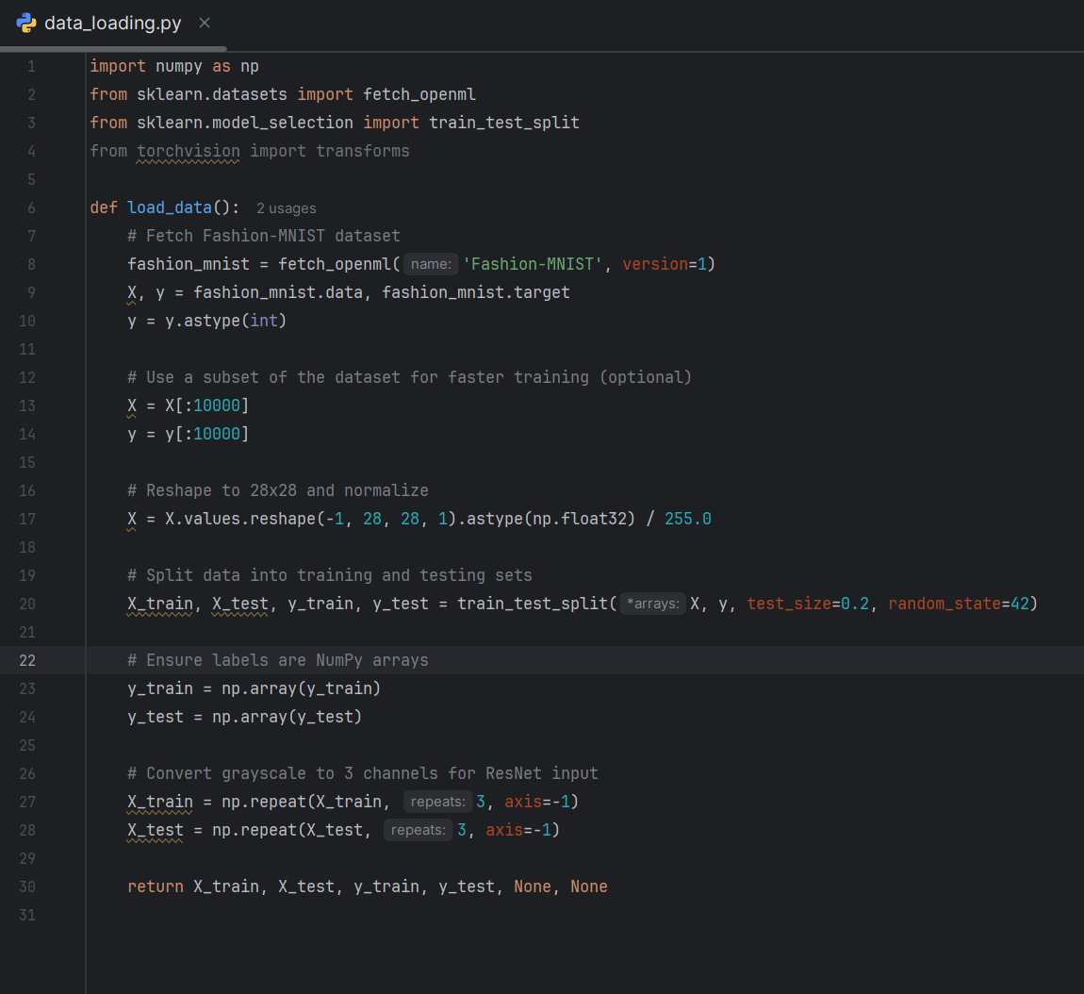
- What It Does:
    - Loads the Fashion-MNIST dataset from OpenML.
    - Normalizes image pixel values to the range [0, 1].
    - Reshapes grayscale images (28x28x1) to RGB format (28x28x3) for compatibility with ResNet-50.
    - Splits the dataset into training and testing sets.
Changes for Logic/Functionality Evaluation:
    - Use the full dataset by removing the subset limit:
Remove or comment out this line:
Changes for Runtime Concerns:
    - Limit the dataset size to reduce runtime:
Add these lines to limit dataset size:
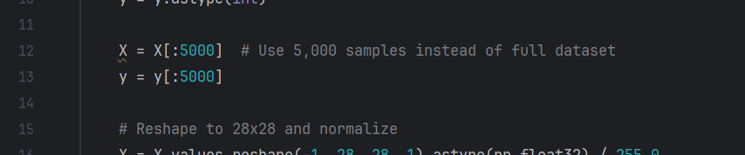

2. models.py
Purpose:
This file defines and trains a ResNet-50 model, fine-tuned for Fashion-MNIST classification.
Key Functions and Methods:
- train_resnet50(X_train, y_train, X_test, y_test):
- 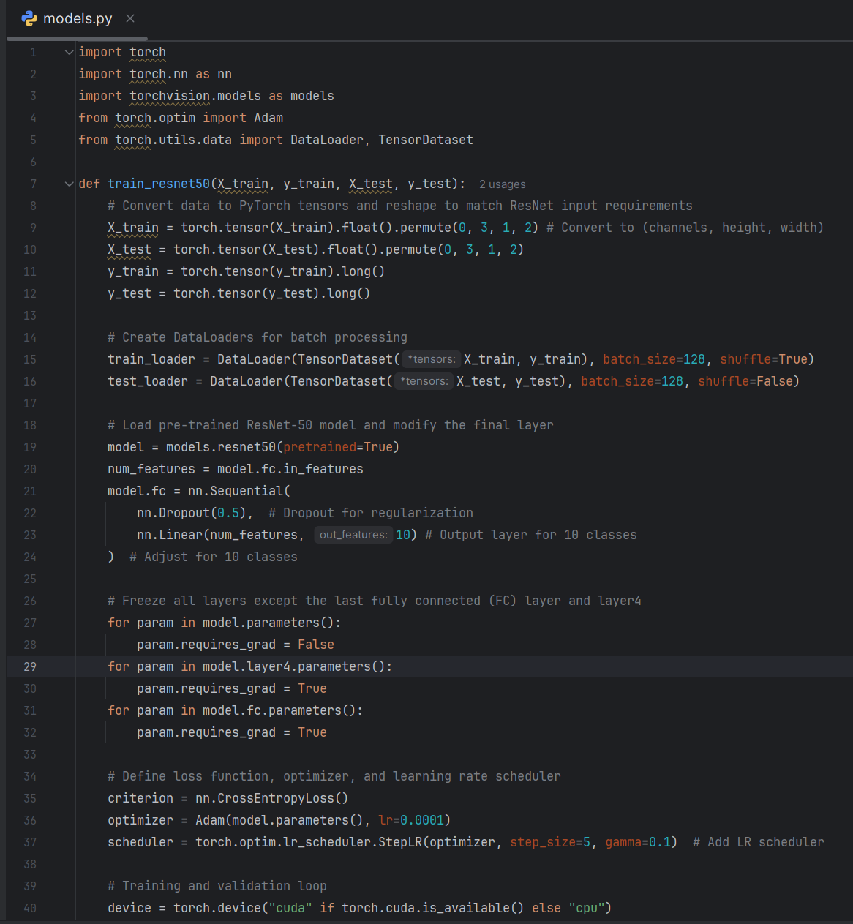
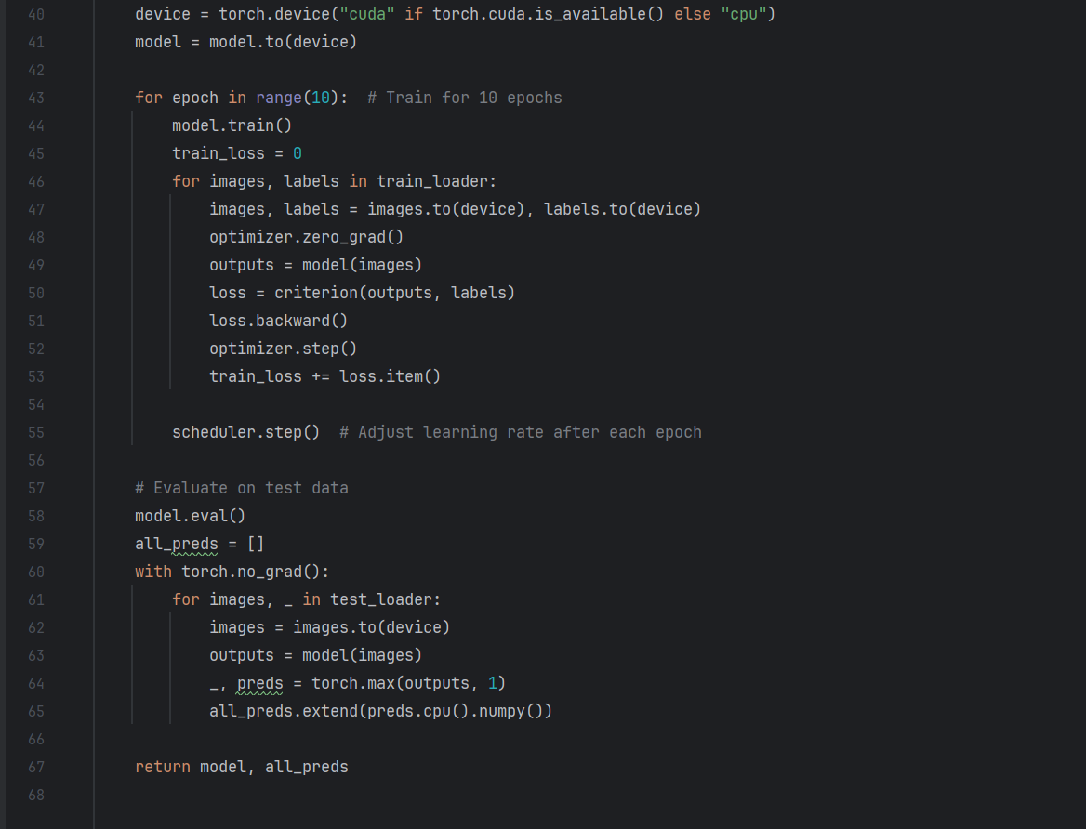
- What It Does:
    - Converts input data to PyTorch tensors and reshapes it to fit the ResNet-50 model.
    - Loads a pre-trained ResNet-50 model and modifies its final fully connected layer to output 10 classes.
    - Freezes all layers except the last fully connected layer and the last convolutional block (layer4).
    - Trains the model over a specified number of epochs using cross-entropy loss and Adam optimizer.
    - Returns the trained model and predictions for the test set.
Changes for Logic/Functionality Evaluation:
    - Unfreeze all layers for complete fine-tuning:

    - Increase the number of training epochs for better performance:
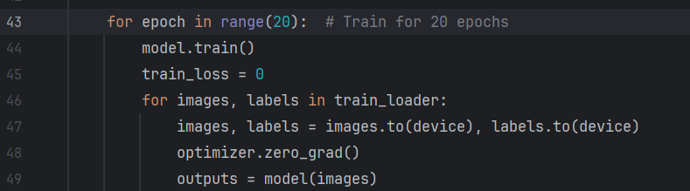
Changes for Runtime Concerns:
    - Reduce the number of training epochs:

    - Freeze all layers except the final fully connected layer to minimize computation:
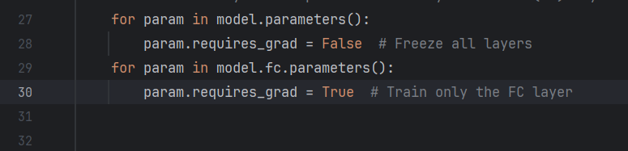

3. evaluation.py
Purpose:
This file evaluates the trained model’s performance on the test set.
Key Functions and Methods:
- evaluate_model(y_test, y_pred, model_name):
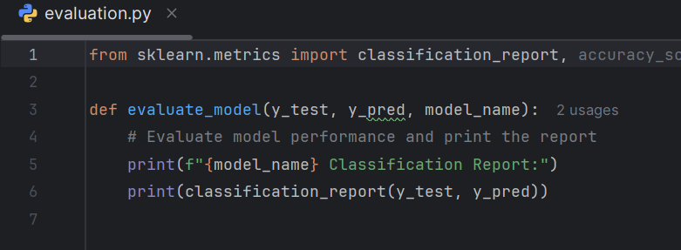
- What It Does:
    - Generates a classification report and accuracy score using sklearn.
    - Prints a summary of the model’s precision, recall, and F1-score for each class.

4. visualization.py
Purpose:
This file visualizes the first 10 test images along with their true and predicted labels.
Key Functions and Methods:
- plot_images(images, labels, predicted_labels=None):
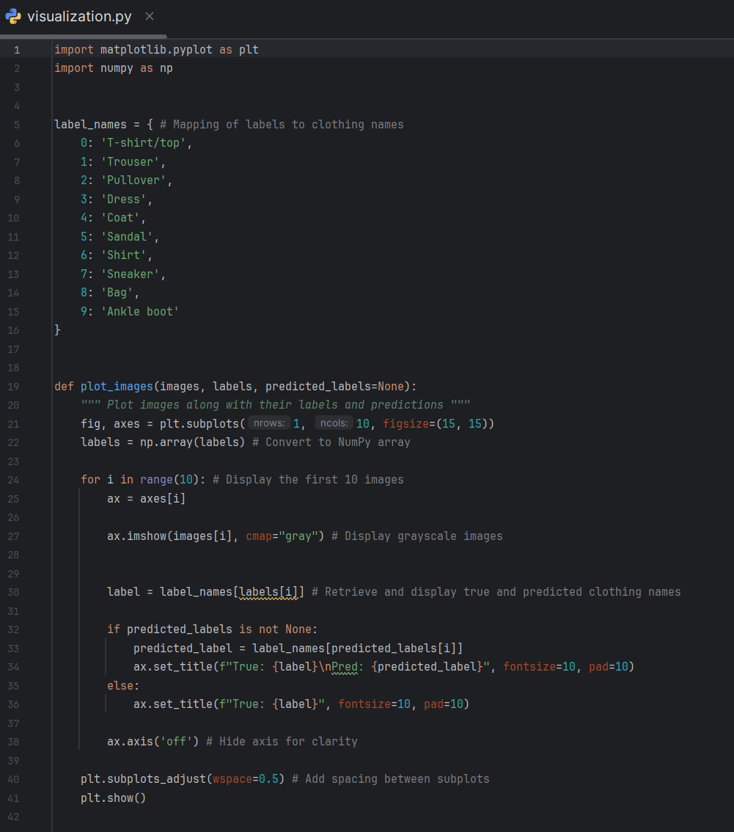
- What It Does:
    - Plots the first 10 images from the test set.
    - Displays the true labels and predicted labels (if provided).
Changes for Logic/Functionality Evaluation:
    - Ensure compatibility with larger input images by updating the reshape logic:

Changes for Runtime Concerns:
    - Skip visualization entirely by commenting out the call in main.py:
    - Comment out this line:

5. main.py
Purpose:
This file orchestrates the entire workflow of the project, including data loading, model training, evaluation, and visualization.
Key Workflow Steps:
- Data Loading:
    - Calls load_data() to prepare the dataset.
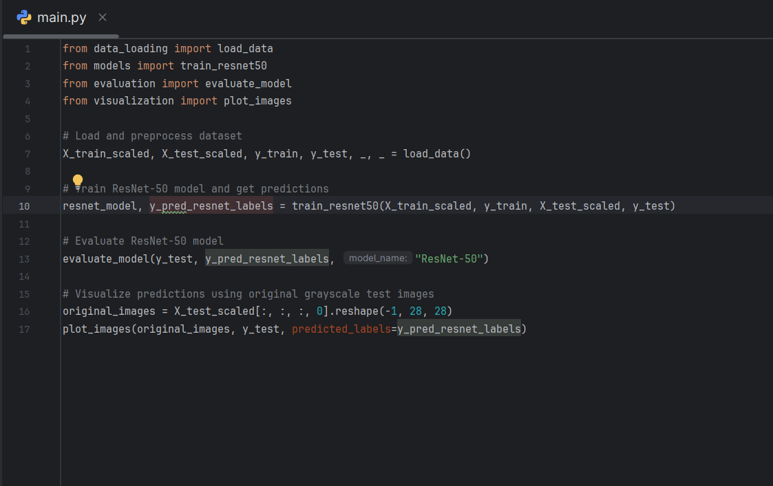
- Model Training:
    - Calls train_resnet50() to train and fine-tune the ResNet-50 model.
- Evaluation:
    - Calls evaluate_model() to generate and print a classification report.

- Visualization:
    - Calls plot_images() to visualize the results.
Logic/Functionality Evaluation:
    - Ensure the model trains on the full dataset and all layers are trainable.
Changes for Runtime Concerns:
    - Limit the dataset size and reduce training epochs.

Analysis of Results

The model achieved a test accuracy of approximately 62% on the Fashion-MNIST dataset, indicating moderate performance. While certain classes such as "Trousers" and "Ankle Boots" exhibited high precision and recall, others like "Shirt" and "Pullover" were more challenging to classify. This discrepancy is likely due to the visual similarity between some classes, such as "Shirt" and "Coat."
The inclusion of pre-trained ResNet-50 features allowed the model to learn effectively from the relatively small Fashion-MNIST dataset. However, the results could be improved further with additional data augmentation, hyperparameter tuning, or more training epochs.

Conclusion and Future Works
This project demonstrates the potential of transfer learning for image classification tasks with limited datasets. While the current results are promising, several avenues exist for improvement:
- Hyperparameter Tuning:
    - Experiment with different learning rates, optimizers, and batch sizes to optimize training.
- Data Augmentation:
    - Apply advanced augmentation techniques, such as elastic deformations or color jitter, to increase dataset diversity.
- Use of Alternative Models:
    - Fine-tune other architectures like EfficientNet or MobileNet for comparison.
- Experimentation with Full Dataset:
    - Train the model on the entire Fashion-MNIST dataset to improve generalization.
- Integration with Real-World Applications:
    - Extend the model for real-time clothing classification or fashion recommendation systems.

Overall, the project provides a strong foundation for leveraging deep learning in image classification tasks and can be extended further for more sophisticated applications.

